1.2.8
Recording Media Files Enhance

Index
Index 2
Purpose for the Function 3
Description of the Function 4
Requirement Limitation 6
Related Subsystem 7
To Be Determined 8
References 9

Requirement Number: ED1020801
Requirement Title:Recording Media Format -MP4 Enhance

Purpose for the Function
- 解掉Etrocenter host不正常斷電,或streaming server crash之後,正在儲存的mp4 file都會損壞無法讀取
- 可以讓playback作instant play

Description of the Function
- Tricky recording
  - 原有錄影作法是先將每個frame循序寫入檔案,在結檔時,再將每個frame 在檔案的position寫入frame data後面的moov atom box
  - 改變錄影資料為
    - 在mdat之前空出0x80000大小的buffer-size(30fps*10min),預留給moov使用
    - 錄寫I-frame時,即時更時moov資料
修改前檔案結構
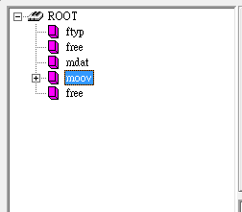
修改後檔案結構
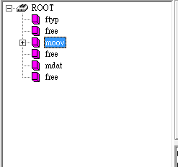
- Repair
  - 當streaming server啟動時,recording server會收到streaming event通知,recording server即依據 streaming server啟動時間,往前搜尋未結檔的錄影資料,作修護動作,更改檔案名稱,update資料庫
  - when
    - recording server 啟動時
    - streaming server 啟動時
  - who
    - recording server
  - how
1.query file that is damage
2.Select filename from ec_recording_file where endtime is null and starttime < GETDATE() and crash is null;
3.open mp4 file, seek mp4-atom-box-"moov" get latest write time
4.calculate moov actual size, other blank replace with free atom
5.rename media-file from mac-port-chanelId-starttime.mp4 to mac-port-chanelId-starttime-endtime.mp4

Requirement Limitation
instant playback was not in this scope

Related Subsystem
EVStream Service
EVRecording Service
Database - ec_recording_file

To Be Determined
event recording的處置方式 event recording目前仍為一個event package為一個檔案,考慮程式效率與儲存空間經濟,仍待研究將多個event package寫入同一個檔案

References
ISO-IEC-14496-12
ISO-IEC-14496-14

